TEAM4OARS

Software Project Management Plan
(SPMP)

LOC: 1000

Cost in dollars: $45,816

Effort in Months: 7.6

Version 2.0

Signature Block

COSC 4351 | Name Signature | Date
SE Team Leader | Bertol Salgado
SE SQA | Ben Wightman

Outline
Revision Chart
Preface
Contents
1. Introduction
1.1 Project Overview
1.2 Project Deliverables
1.3 Evolution of the Software Project Management Plan
1.4 Reference Materials
1.5 Definitions and Acronyms
2. Project Organization
2.1 Process Model
2.2 Organizational Structure
2.3 Organizational Boundaries and Interfaces
2.4 Project Responsibilities
3. Managerial Process
3.1 Management Objectives and Priorities
3.2 Assumptions, Dependencies, and Constraints
3.3 Risk Management
3.4 Monitoring and Controlling Mechanisms
3.5 Staffing Plan
4. Technical Process
4.1 Methods, Tools, and Techniques
4.2 Software Documentation
4.3 Project Support Functions
5. Work Packages, Schedule, and Budget
5.1 Work Packages
5.2 Dependencies
5.3 Resource Requirements
5.4 Budget and Resource Allocation
5.5 Schedule
6. Additional Components
7. Index
8. Appendices

Detailed Contents

Revision Chart
Version | Primary Author(s) | Description of Version | Date Completed
Draft | Bertol Salgado | Initial draft created for distribution and review comments | 04/02/2016
Preliminary | TBD | Second draft incorporating initial review comments, distributed for final review | TBD
Final | TBD | First complete draft, which is placed under change control | TBD
Revision 1 | TBD | Revised draft, revised according to the change control process and maintained under change control | TBD
Revision 2 | TBD | Revised draft, revised according to the change control process and maintained under change control | TBD
etc. | TBD | TBD | TBD

Preface

The Software Management Plan details the approach the team will take towards the project. The document includes how the project is organized, the processes used, schedule, and budget

Contents
Contents

1.0 Introduction 4
1.1 Project Overview 4
1.2 Project Deliverables 4
1.3 Evolution of the Software Project Management Plan 5
1.4 Reference Materials 5
1.5 Definitions and Acronyms 5
2.0 Project Organization 6
2.1 Process Model 6
2.2 Organizational Structure 6
2.3 Organizational Boundaries and Interfaces 8
2.4 Project Responsibilities 8
3.0 Managerial Process 8
3.1 Management Objectives and Priorities 8
3.2 Assumptions, Dependencies, and Constraints 8
3.3 Risk Management 9
3.4 Monitoring and Controlling Mechanisms 9
3.5 Staffing Plan 9
4.0 Technical Process 9
4.1 Methods, Tools, and Techniques 9
4.2 Software Documentation 9
4.3 Project Support Functions 10
5.0 Work Packages, Schedule, and Budget 10
5.1 Work Packages 11
5.2 Dependencies 11
5.3 Resource Requirements 11
5.4 Budget and Resource Allocation 11
5.5 Schedule 13
6.0 Additional Components 13
7.0 Index 14
8.0 Appendices 14

List of Figures
Figure 5.1
COCOMO Model
Figure 5.2
MS Project Schedule

1.0 Introduction

1.1 Project Overview
This Project involves the design of a Website that will provide the tools needed to manage an apartment complex. It will provide the tools for owners and staff to use in the rental process. Also it will provide a portal for the tenant where they can view their lease information and place a complaint or add a testimonial.
The Project will go through multiple faces through February 2016 through April 2016. These phases are inception, elaboration, construction, and transition. The estimated cost is $45,816 taking about 7.6 person-months. The Project uses COCOMO II Constructive Cost Model to calculate the estimate cost of the project.

1.2 Project Deliverables
- SE Team Project with Line Numbers for UML USE CASE DIAGRAM
- SE Team Project with Line Numbers for UML OOA MVC CLASS DIAGRAM
- Software Requirements Specification
- Team Project Report
- ERD Model
- Date Requirements Specifications (DRS)
- Software Project Management Plan
- Website fully functional
All the deliverables were given to customer via electronic and hard copy.

1.3 Evolution of the Software Project Management Plan
The initial draft of this document is available for review as of 4/2/16. SQA will review the document and suggest any changes. The authors will update the document based on the feedback provided
Current Version: Draft 4/2/16
Version | Primary Author(s) | Description of Version | Date Expected
Draft | Bertol Salgado | Initial draft created for distribution and review comments | 4/2/16
Preliminary | TBD | Second draft incorporating initial review comments, distributed for final review | TBD
Final | TBD | First complete draft, which is placed under change control | TBD
Revision 1 | TBD | Revised draft, revised according to the change control process and maintained under change control | TBD
etc. | TBD | TBD | TBD

1.4 Reference Materials
- COCOMO II – Constructive Cost Model
- MS Project
- Unified Process

1.5 Definitions and Acronyms
- COCOMO II – Estimating cost software
- Unified Process – Iterative and incremental software development process
- ERD – Entity Relation Diagram
- SRS – Software Requirement Specifications
- DRS – Data Requirements Specifications

2.0 Project Organization

2.1 Process Model
Describe the following items:
- Our life cycle process is similar to that of the Agile Software Development, but with more documentation. Roughly once every two weeks TEAM4OARS meets to discuss in detail, what needs to be done and to organize and distribute work and information. Two days a week the team briefly meets for less than 10 minutes to quickly answer any questions or concerns.
- The project has four major milestones. The first is the Read Team Deliverables. This includes basic textual analysis. This milestone’s due date is February 17. The second is the Purple Team Deliverables. This includes any corrections that are needed on the Red deliverables plus new requirements documents. This milestone’s due date is March 21. The third is the Blue Team Deliverables. This includes more requirements documents and completing the web site pages. This milestone’s due date is April 4. The last milestone is the completed software which is due April 20.
Work Product Name | Planned Completion Date | Placed Under Change Control? | Deliverable to Customer? | People Who Must Sign Off on the Work Product
Software Project Management Plan  This is the controlling document for managing a software project, and it defines the technical and managerial processes necessary to deliver the project requirements. | 04/02 | Yes | No | Team Leader
Black Box Test Cases  This contains the test cases based on the requirements. | 04/15 | Yes | No | Team Leader, DBAs, TMs, and SQAs
Feasibility Study  This is the document for understanding how much the software project could cost and if it is possible to create. | 02/06 | Yes | No | Team Leader, TMs, DBAs and SQA
Input Forms and Output Reports  This document shows any and all input forms and what the proper outputs from these forms would look like. | 02/06 | Yes | Yes | Team Leader, TMs, DBAs and SQA
UML OOA MVC Class Diagram  This is the document that shows the analysis of the requirements and maps out the classes and their connections to each other. | 04/18 | Yes | No | Team Leader, TMs, and SQAs
UML OOA Use Case Diagram  This document shows the actors and the different methods in the controller that the actors have access to. | 04/18 | Yes | No | Team Leader, TMs, and SQAs
Software Requirements Specification  This is the requirements document which gives the exact specifications for what the software project needs and where it can be found. | 03/21 | Yes | Yes | Team Leader, TMs, and SQAs
Team Project Report  This document gives an outline to everything that is needed to understand the project, much like an instruction manual. | 04/18 | Yes | Yes | Team Leader, DBAs, TMs and SQAs
Web Site Design  This document simply lays out how the website it to look and where all of the elements are located. | 03/21 | Yes | No | Team Leader, TMs, and SQAs
Data Requirements Specification  Much like the Software Requirements Specification, this document pertains to the data stored in the database. | 03/21 | Yes | Yes | Team Leader, DBAs, and SQAs
ERD Modeling  This document displays entities and their relationships to each other. This pertains to the database side of the document. | 04/04 | Yes | No | Team Leader, DBAs, and SQAs

2.2 Organizational Structure
Team Leader
Overall operations and division of labor

Software Quality Assurance members
Maintaining quality of every part of the software and its documentation

Team Members
In charge of creating the front of the software

Database Administrators
Create and maintaining the database

2.3 Organizational Boundaries and Interfaces
- Team Leader: Bertol Salgado communicates with the Customer: Victoria Hilford
- Customer: Victoria Hilford provides feedback to Team Leader: Bertol Salgado

2.4 Project Responsibilities
Database Administrators are responsible for creating the database and update the documents ERD and Data Requirements Specifications. Team Leader is responsible for setting due dates, and making sure that the product is getting prepared on time. Software Quality Assurance members are responsible for allocating time for meetings and making sure that everything that is completed is up to the quality that is required. The team members are responsible for the development of the website functionality

3.0 Managerial Process

3.1 Management Objectives and Priorities
The priority is to disperse work evenly between members to make sure the project gets completed in a timely manner without placing too much work on one person. Using third party or new software will be undertaken by multiple members to better understand the software and allow that it is adapted properly. Frequent tests will be run to find and fix errors as well as guarantee the quality is up to the required standard.

3.2 Assumptions, Dependencies, and Constraints
We assume that the customer will provide the necessary data to test the system before final release. Also that any new requirement will be place on hold after the development process has started.

3.3 Risk Management
Risks will be identified throughout the testing phase which will help find any problems that could make the website unsecure. The SQA will provide feedback on all parts of the project and make sure there is no missing functionality or possible security problems

3.4 Monitoring and Controlling Mechanisms
TEAM4OARS will have sections of work along with their due dates. Using a task board, work can be submitted for verification a couple of days before the due date. This will provide enough time to review and make any changes if needed. There will be a staff meeting once week to report the progress on the project and answer any questions.

3.5 Staffing Plan
Seven members will be needed to conduct the project. The skill level will be measure from moderate to advance for this project. The project will start late January and last for three months. Members volunteer for their roles and are confirmed as members by the Team Leader, who is also a volunteer. There is mild training which is administered periodically throughout the three months. The team is as follows:
Team Leader – Bertol Salgado
SQA – Ben Wightman
Database Administrators – Joseph Nguyen
Stephen Carver
Team Members – Joshua Wilburn
Ali Elsaadi M
Garrett Bellomy

4.0 Technical Process

4.1 Methods, Tools, and Techniques

TEAM4OARS will be using Unified Process for software development. Some of the tools and software we will be using are:

-MS Visual Studio 2015: To create, develop, and debug TEAM4OARS software.

-TortoiseSVN: Version control tool.

-MS Word: For creating software documents and UML diagrams.

-MS Project: To create and track the project schedule.

-MSSQL Server: Create Database.

-COCOMO II: To estimate resources and scheduling.

4.2 Software Documentation

TEAM4OARS will be responsible for providing extensive documentation of its software. Below is a list and their use of these documents. It will provide trouble less development and maintenance of TEAM4OARS software.

Software Project Management Plan: Contains list of documents for TEAM4OARS, Scheduling, plans, and TEAM4OARS goals.

Web Site Design: This document contains basic template for TEAM4OARS website and its functions.

UML OOA MVC CLASS DIAGRAM: Shows TEAM4OARS class view and how they are related.

UML USE CASE DIAGRAM: Shows Actors interaction with TEAM4OARS software.

ERD Modeling: This document contains entities and their relationship for TEAM4OARS database.

Data Requirements Specification: In this doc shows attribute’s access type and ERD model.

Relational Model: Shows 1NF, 2NF, and 3NF Table of TEAM4OARS database.

Black Box Testing: Shows acceptable case for TEAM4OARS data.

These documents and their contents are subject to change as client provides more feedback and new information is discovered.

4.3 Project Support Functions

UML OOA MVC CLASS DIAGRAM

UML USE CASE DIAGRAM

Web Site Design

ERD Modeling: Data Requirements Specification

Relational Model

Black Box Testing

5.0 Work Packages, Schedule, and Budget

5.1 Work Packages
Work Package
4/4 – 4/13
Task Name | Duration
UCLogin | 8 days
UCChat | 8 days
UCDisplayTenantInfo | 8 days
UCLookupRentalAgreement | 8 days
UCPayRent | 8 days
UCEnterComplaint | 8 days
EnterTestimonial | 8 days
UCCreateRental | 8 days
UCUpdateComplaint | 8 days

4/8 – 4/19
Task Name | Duration
UCLookupTestimonial | 8 days
UCListAptVacant | 8 days
UCListAutoMake | 8 days
UCListLeases | 8 days
UCListRentCollected | 8 days
UCListPendingComplaints | 8 days
UCListStaffRentalDetails | 8 days
UCListStaffAptDetails | 8 days
UCListTenants | 8 days
UCListPayments | 8 days

5.2 Dependencies

For TEAM4OARS Blue Iteration depends on Red Iteration to be successfully completed. TEAM4OARS end product depends on both Green and Blue Iteration to be successfully completed.

5.3 Resource Requirements
TEAM4OARS consists of seven members; every member of team will be required to write contributing code for the website. Resources required for this project are MS SQL server for DBAs, Computer with Visual studio 2015 for each team members, and 7.6 person-months from each team members. Below is list of TEAM4OIES members.

Role | Name
Team Leader | Bertol Salgado
SQA | Ben Wightman
DBA | Joseph Nguyen
DBA | Stephen Carver
Team Member | Joshua Wilburn
Team Member | Ali Elsaadi M
Team Member | Garrett Bellomy

5.4 Budget and Resource Allocation
Please Refer to Figure 5.1 for Budget and Resource Calculation

Figure 5.1

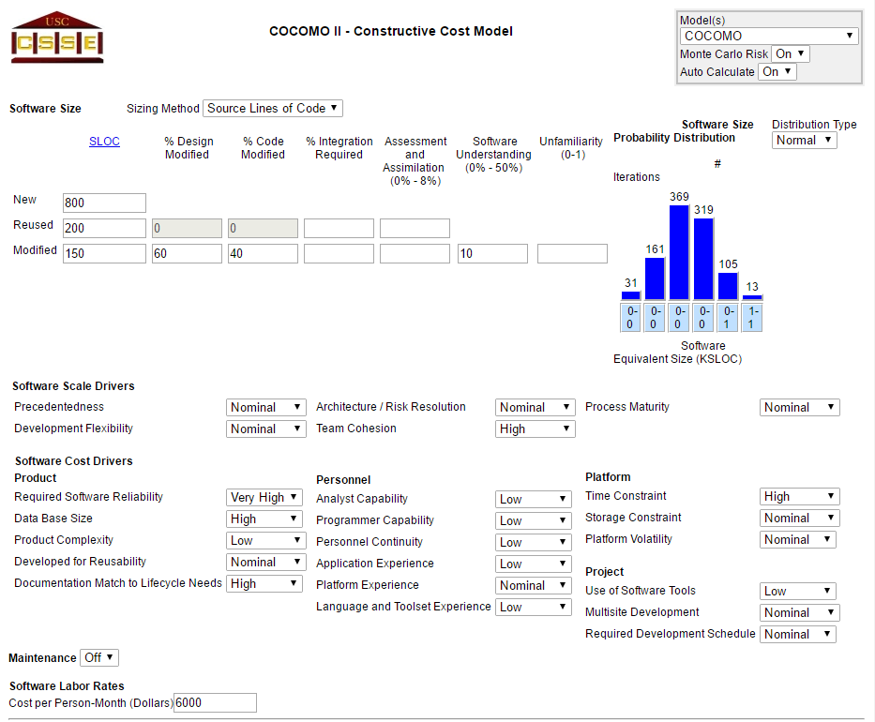

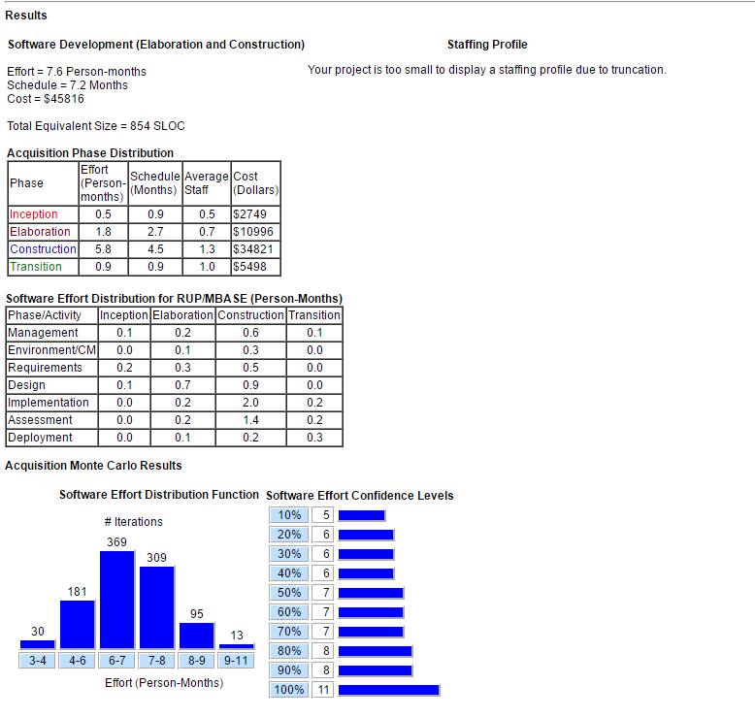

Schedule

Figure 5.2

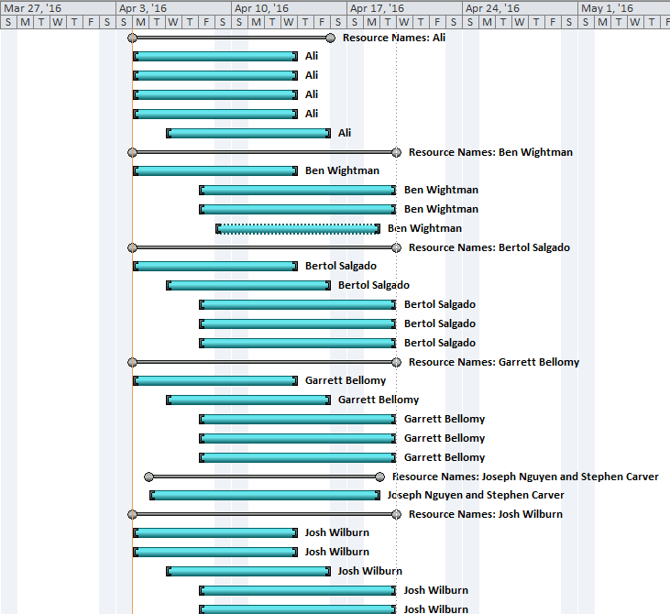

6.0 Additional Components
COCOMO used for calculating software cost in dollars and time.
http://csse.usc.edu/csse/research/COCOMOII/cocomo_main.html
MS Project used manage the project schedule.
https://products.office.com/en-us/project/project-and-portfolio-management-software

7.0 Index
Not Needed as Electronic Search function can be used

8.0 Appendices
Document does not contain any appendices

Document Control

Change History

Table 1: TLs entries (assigned work and due dates) before releasing to the team
Revision | Name | Due Date | Description
1.1 | TL Bertol Salgado | 03/30/16 | Complete SPMP
1.1 | SQA Ben Wightman | 04/01/16 | Review Document

Table 2: Entries when work completed (SVN Commit Comment matches Description)
Revision | Name | Completed Date | Description
1.1 | TL Bertol Salgado | 4/4/16 | Completed SPMP
1.1 | SQA Ben Wightman | 4/4/16 | Review and made necessary changes

Table 3: TL entry for RED DELIVERABLES (SVN Commit Comment matches Description)
Revision | Name | Due Date | Description
2.0 | TL Bertol Salgado | 4/4/16 | I changed Version to 2.0

Document Storage
This file is stored in SVN at https://svn.cs.uh.edu/svn/cosc4351/team4/TEAM PROJECT DELIVERABLES/Software Project Management Plan.doc.

